‘60 years practising occupational medicine’
You are warmly invited to Massey University’s Centre for Public Health Research public lecture presented by Professor Bill Glass who is considered the godfather of occupational health in New Zealand.
, 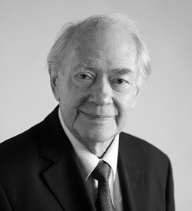
In January 1958, age 26, Bill Glass signed on as ship’s doctor for the Port Hobart, a cargo vessel with 12 passengers bound for London.
He was inexperienced, had no job to go to, nowhere to stay. Why was he going? Where would it lead? He knew he had to get away from New Zealand to visit the “old world” – the world his father referred to as “home”.
In reflecting on these 60 years, Bill will refer to the influences, the individuals, the ideas and the attitudes that helped to mould him into an occupational physician.
A career with its high and lows but at its conclusion saw him named as Senior New Zealander of the Year for 2019 and one of the 150 Otago University Alumni Heroes – 150 for the 150 years since the founding of Otago University.
Wednesday, August 21
5.00 – 7:00 pm
Venue
Te Ara Hihiko - The Pit, Block 12, Room B09, Level B/C
Entrance E, Tasman Street, Massey University

Register here.
There will be a networking opportunity with drinks and nibbles from 5.00 – 5:30 pm (Foyer – Level C, Block 12). You are welcome to bring guests and share the invitation with your network.

